[GOOGLE EARTH ENGINE](EE01%20Earth%20Engine%20(EE).docx) [APPLICATION PROGRAMMING INTERFACE](EE05%20%20%20The%20EE%20API.docx) [CAPABILITIES](EE07%20%20%20%20%20%20API%20Capabilities.docx)

PROCESSING **STRING** [VARIABLES](EE13%20%20%20%20%20%20%20%20%20Variables.docx)

A string is an EE variable object that represents a sequence of text characters such as letters, numerals, and symbols. Strings can be processed by using operations

of the types listed below, which vary according to the nature of that processing. Each operation name is linked to a separate page describing that operation.

**CREATING** STRINGS ee.Stringprompt

**EDITING** STRINGS string.cat string.replace

**REPRODUCING** STRINGS

AS **LISTS** string.split string.match

**QUERYING** STRINGS

FOR **SUBSTRINGS** string.slice

**COMPARING** STRINGS string.index string.rindex  ee.Algorithms.IsEqual(string)

**MEASURING** STRINGS string.length

**DOCUMENTING** STRINGS string.getInfo  ee.Algorithms.String Algorithms.Describe(string)

string.toString string.serialize

**PRESENTING** STRINGS

IN **PRINT** print(string) console.log(string) alert(string) confirm(string)

[GOOGLE EARTH ENGINE](EE01%20Earth%20Engine%20(EE).docx) [APPLICATION PROGRAMMING INTERFACE](EE05%20%20%20The%20EE%20API.docx) [CAPABILITIES](EE07%20%20%20%20%20%20API%20Capabilities.docx)

**CREATING** STRING [VARIABLES](EE13%20%20%20%20%20%20%20%20%20Variables.docx)

ee.String creates a new string from a specified sequence of characters.

newString = ee.String( characters )

The specified sequence of characters, given in quotes

The new string

var TheSTRING = ee.String( 'This statement is false.' );

print( TheSTRING );

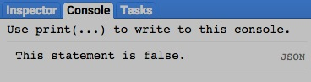

[GOOGLE EARTH ENGINE](EE01%20Earth%20Engine%20(EE).docx) [APPLICATION PROGRAMMING INTERFACE](EE05%20%20%20The%20EE%20API.docx) [CAPABILITIES](EE07%20%20%20%20%20%20API%20Capabilities.docx)

**CREATING** STRING [VARIABLES](EE13%20%20%20%20%20%20%20%20%20Variables.docx)

prompt creates a new string from user response to a specified message presented in a pop-up message box.

newString = prompt( outgoingMessage, *defaultResponse* )

A new string to be assumed if none is provided in response through the message box

The specified message, given as a string

The new string

var response = prompt( "Please, enter your response below and click OK.", "YOUR RESPONSE" );

alert( "Your response was as follows: " + response );

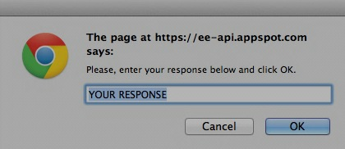

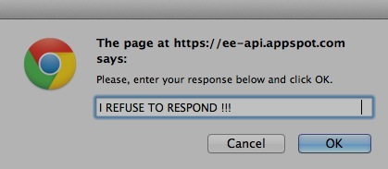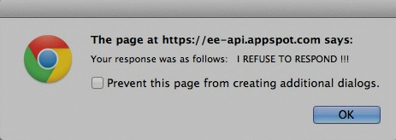

[GOOGLE EARTH ENGINE](EE01%20Earth%20Engine%20(EE).docx) [APPLICATION PROGRAMMING INTERFACE](EE05%20%20%20The%20EE%20API.docx) [CAPABILITIES](EE07%20%20%20%20%20%20API%20Capabilities.docx)

**EDITING** STRING [VARIABLES](EE13%20%20%20%20%20%20%20%20%20Variables.docx)

string.cat creates a new string by appending (or “concatenating”) the second of two specified strings to the end of the first of those strings.

newString = leftString.cat( rightString )

The second specified string

The first specified string

The new string

var LeftSTRING = ee.String( "Please Don't" );

var RightSTRING = ee.String( " Read This! " );

var NewSTRING = LeftSTRING.cat( RightSTRING );

print( NewSTRING );

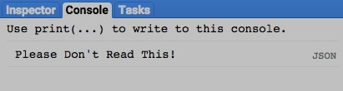

[GOOGLE EARTH ENGINE](EE01%20Earth%20Engine%20(EE).docx) [APPLICATION PROGRAMMING INTERFACE](EE05%20%20%20The%20EE%20API.docx) [CAPABILITIES](EE07%20%20%20%20%20%20API%20Capabilities.docx)

**EDITING** STRING [VARIABLES](EE13%20%20%20%20%20%20%20%20%20Variables.docx)

string.replace creates a string formed by substituting a specified substring for the first substring of a specified string that satisfies a specified regular expression.

Regular expressions are described [here](http://www.w3schools.com/jsref/jsref_obj_regexp.asp).

newString = oldString.replace( regularExpression, replacementString *expressionFlags* )

A string of regular expression flags

The specified substring

The specified regular expression

The specified string

The new string

var OldSTRING = ee.String( "North South East West" );

var NewSTRING = OldSTRING.replace( 'th', 'theast' );

print( OldSTRING, NewSTRING );

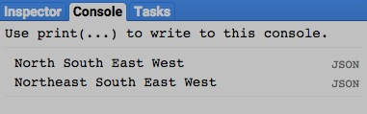

[GOOGLE EARTH ENGINE](EE01%20Earth%20Engine%20(EE).docx) [APPLICATION PROGRAMMING INTERFACE](EE05%20%20%20The%20EE%20API.docx) [CAPABILITIES](EE07%20%20%20%20%20%20API%20Capabilities.docx)

**REPRODUCING** STRING [VARIABLES](EE13%20%20%20%20%20%20%20%20%20Variables.docx) AS **LISTS**

string.split creates a list of the sub-strings formed when a specified string is split at each occurrence of a specified regular expression.

Regular expressions are described [here](http://www.w3schools.com/jsref/jsref_obj_regexp.asp).

newList = oldString.split( regularExpression, *expressionFlags* )

The specified string

The specified regular expression

A string of regular expression flags

The new list

var OldSTRING = ee.String( "North South East West" );

var NewSTRING = OldSTRING.split( ' ' );

print( OldSTRING, NewSTRING );

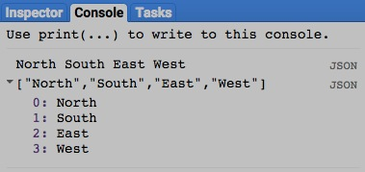

[GOOGLE EARTH ENGINE](EE01%20Earth%20Engine%20(EE).docx) [APPLICATION PROGRAMMING INTERFACE](EE05%20%20%20The%20EE%20API.docx) [CAPABILITIES](EE07%20%20%20%20%20%20API%20Capabilities.docx)

**REPRODUCING** STRING [VARIABLES](EE13%20%20%20%20%20%20%20%20%20Variables.docx) AS **LISTS**

string.match creates a list of all sub-strings of a specified string that satisfy a specified regular expression. Regular expressions are described [here](http://www.w3schools.com/jsref/jsref_obj_regexp.asp).

newList = oldString.match( regularExpression, *expressionFlags* )

The specified string

The specified regular expression

A string of regular expression flags

The new list

var OldSTRING = ee.String( "North South East West" );

var NewSTRING = OldSTRING.match( 'north', 'i' );

print( OldSTRING, NewSTRING );

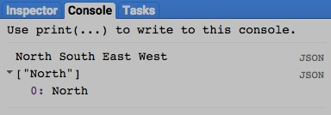

[GOOGLE EARTH ENGINE](EE01%20Earth%20Engine%20(EE).docx) [APPLICATION PROGRAMMING INTERFACE](EE05%20%20%20The%20EE%20API.docx) [CAPABILITIES](EE07%20%20%20%20%20%20API%20Capabilities.docx)

**QUERYING** STRING [VARIABLES](EE13%20%20%20%20%20%20%20%20%20Variables.docx) FOR **SUBSTRINGS**

string.slice creates a new string by replicating the sub-string of a specified string that starts and stops at specified ordinal positions (starting with 0).

newString = oldString.slice( startingPosition, *stoppingPosition* )

The specified position just before which the substring is to stop, given as an integer starting at 0 with negative indices counted backwards from the list’s end

The specified position at which the substring is to start, given as an integer starting at 0 with negative indices counted backwards from the list’s end

The new string

The specified string

var OldSTRING = ee.String( "What does every fine artist hope for?" );

var NewSTRING = OldSTRING.slice( 11, 24 );

print( OldString, NewSTRING );

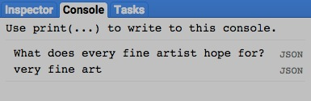

[GOOGLE EARTH ENGINE](EE01%20Earth%20Engine%20(EE).docx) [APPLICATION PROGRAMMING INTERFACE](EE05%20%20%20The%20EE%20API.docx) [CAPABILITIES](EE07%20%20%20%20%20%20API%20Capabilities.docx)

**COMPARING** STRING [VARIABLES](EE13%20%20%20%20%20%20%20%20%20Variables.docx)

ee.Algorithms.IsEqual creates a new Boolean set to True (only) if the first of two specified strings is identical to the other in both structure and content.

newBoolean = ee.Algorithms.IsEqual ( 1stString, 2ndString )

The first specified string

The second specified string

The new Boolean

var The1stSTRING = ee.String( 'abc' );

var The2ndSTRING = ee.String( 'ABC' );

var TrueOrFalse = ee.Algorithms.IsEqual( The1stSTRING, The2ndSTRING );

print( The1stSTRING, The2ndSTRING );

print( 'Is it true or false that those strings are alike? ' );

print( TrueOrFalse );

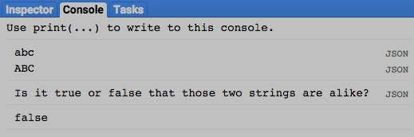

[GOOGLE EARTH ENGINE](EE01%20Earth%20Engine%20(EE).docx) [APPLICATION PROGRAMMING INTERFACE](EE05%20%20%20The%20EE%20API.docx) [CAPABILITIES](EE07%20%20%20%20%20%20API%20Capabilities.docx)

**COMPARING** STRING [VARIABLES](EE13%20%20%20%20%20%20%20%20%20Variables.docx)

string.index creates a new integer indicating the index (i.e. the ordinal position starting with 0) of the initial character of a specified substring in a specified string.

newInteger = 1stOldString.index ( 2ndOldString )

The specified substring

The specified string

The new integer

var TheSTRING = ee.String( "The initial character within the string 'character'\

appears at the following position within this sentence." );

var NewINTEGER = TheSTRING.index('character');

print( TheSTRING, NewINTEGER );

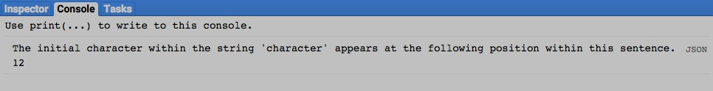

[GOOGLE EARTH ENGINE](EE01%20Earth%20Engine%20(EE).docx) [APPLICATION PROGRAMMING INTERFACE](EE05%20%20%20The%20EE%20API.docx) [CAPABILITIES](EE07%20%20%20%20%20%20API%20Capabilities.docx)

**COMPARING** STRING [VARIABLES](EE13%20%20%20%20%20%20%20%20%20Variables.docx)

string.rindex creates a new integer indicating the index (i.e. the ordinal position starting with 0) of the final character of a specified substring in a specified string.

If no such substring is found, the new integer is set to -1.

newInteger = 1stOldString.rindex ( 2ndOldString )

The specified substring

The specified string

The new integer

var TheSTRING = ee.String( "The first character of the final substring 'character' here is at the following position." );

var NewINTEGER = TheSTRING.rindex('character');

print( TheSTRING, NewINTEGER );

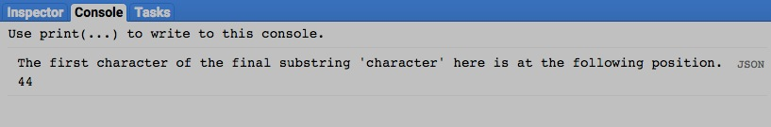

[GOOGLE EARTH ENGINE](EE01%20Earth%20Engine%20(EE).docx) [APPLICATION PROGRAMMING INTERFACE](EE05%20%20%20The%20EE%20API.docx) [CAPABILITIES](EE07%20%20%20%20%20%20API%20Capabilities.docx)

**MEASURING** STRING [VARIABLES](EE13%20%20%20%20%20%20%20%20%20Variables.docx)

string.length creates a new integer indicating the number of characters in a specified string.

newInteger = oldString.length ( )

The specified string

The new integer

var TheSTRING = ee.String( 'The number of characters in this character string is as follows.' );

var NewINTEGER = TheSTRING.length( );

print( TheSTRING, NewINTEGER );

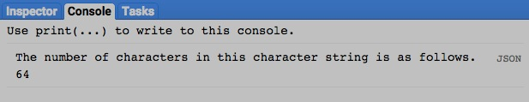

[GOOGLE EARTH ENGINE](EE01%20Earth%20Engine%20(EE).docx) [APPLICATION PROGRAMMING INTERFACE](EE05%20%20%20The%20EE%20API.docx) [CAPABILITIES](EE07%20%20%20%20%20%20API%20Capabilities.docx)

**DOCUMENTING** STRING [VARIABLES](EE13%20%20%20%20%20%20%20%20%20Variables.docx)

ee.Algorithms.Describe , ee.Algorithms.String , and string.getInfo

each creates a JSON-compatible text object

representing a specified string.

newObject = ee.Algorithms.Describe ( oldString )

ee.Algorithms.String( oldString )

and oldString.getInfo( )

The specified string

The new object

var OldSTRING = ee.String( 'This statement is false.' );

print( 'New string from the original string', OldSTRING );

print( 'New string from ee.Algorithms.Describe', ee.Algorithms.Describe( OldSTRING ) );

print( 'New string from ee.Algorithms.String', ee.Algorithms.String( OldSTRING ) );

print( 'New string from string.getInfo( )', OldSTRING.getInfo( ) );

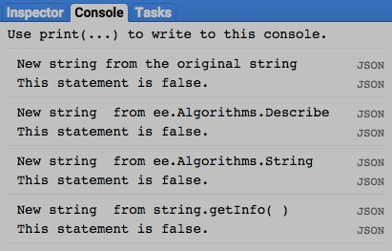

[GOOGLE EARTH ENGINE](EE01%20Earth%20Engine%20(EE).docx) [APPLICATION PROGRAMMING INTERFACE](EE05%20%20%20The%20EE%20API.docx) [CAPABILITIES](EE07%20%20%20%20%20%20API%20Capabilities.docx)

**DOCUMENTING** STRING [VARIABLES](EE13%20%20%20%20%20%20%20%20%20Variables.docx)

string.toString and .serialize each creates a new string presenting information on a specified string.

newString = oldString.toString ( )

and oldString.serialize( )

The new string

The specified geometry

var OldSTRING = ee.String( 'This statement is false.' );

print( 'New string from the original string', OldSTRING );

print( 'New string from string.toString( )', OldSTRING.toString( ) );

print( 'New string from string.serialize( )', OldSTRING.serialize( ) );

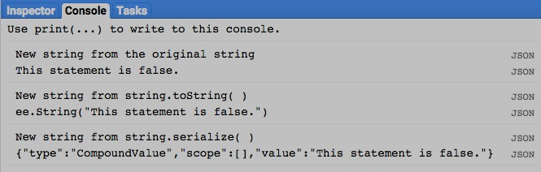

[GOOGLE EARTH ENGINE](EE01%20Earth%20Engine%20(EE).docx) [APPLICATION PROGRAMMING INTERFACE](EE05%20%20%20The%20EE%20API.docx) [CAPABILITIES](EE07%20%20%20%20%20%20API%20Capabilities.docx)

**PRESENTING** STRING [VARIABLES](EE13%20%20%20%20%20%20%20%20%20Variables.docx) IN **PRINT**

print ( string ) and console.log ( string ) present the text representation of a specified number in the console.

print( oldString ) or console.log( oldString )

The specified number

print( 'This is a text string.' );

console.log( 'This is a text string.' );

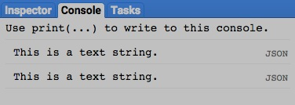

[GOOGLE EARTH ENGINE](EE01%20Earth%20Engine%20(EE).docx) [APPLICATION PROGRAMMING INTERFACE](EE05%20%20%20The%20EE%20API.docx) [CAPABILITIES](EE07%20%20%20%20%20%20API%20Capabilities.docx)

**PRESENTING** STRING [VARIABLES](EE13%20%20%20%20%20%20%20%20%20Variables.docx) IN **PRINT**

alert ( string ) and confirm( string ) presents the text representation of a specified string in a pop-up message box.

alert( oldString ) or confirm( oldString )

The specified string

alert( 'This is a text string.' );

confirm( 'This is a text string.' );

